CS 340 README Template

About the Project/Project Title
The AnimalShelter class manages an animal database in MongoDB by providing full CRUD operations creating, reading, updating, and deleting records. It connects to a local MongoDB instance and uses Python with PyMongo to perform routine data-handling tasks.

Motivation
CRUD operations are routine in any database workflow, but formatting queries and handling errors can become repetitive and time-consuming. Standardizing and reusing this structure helps reduce that tedious overhead.

Getting Started
· MongoDB instance with a user account (aacuser) and a database (AAC) with the animals collection.
· pymongo library installed

Installation
Software
- Python 3.x
- MongoDB Server
- PyMongo
Install PyMongo
pip install pymongo

Usage
Use this space to show useful examples of how your project works and how it can be used. Be sure to include examples of your code, tests, and screenshots.

Example

animal = {

"name": "Ben",

"animal_type": "Dog",

"breed": "Labrador",

"age_upon_outcome": "2 years"

}

result = shelter.create(animal)

print(result)

Return Value

True if insert is successful

False if an error occurs

Read

Retrieves documents matching a query.

Syntax

shelter.read(query)

Example

results = shelter.read({"name": "Ben"})

print(results)

Return Value

List of matching documents

Empty list if no documents are found or an error occurs

Update

Updates one or more documents that match the query criteria.

Syntax

shelter.update(query, new_values)

Example

updated = shelter.update(

{"name": "Ben"},

{"name": "Benji"}

)

print("Documents Updated:", updated)

Return Value

Number of modified documents

Delete

Deletes documents matching the query criteria.

Syntax

shelter.delete(query)

Example

deleted = shelter.delete({"name": "Benji"})

print("Documents Deleted:", deleted)

Return Value

Number of deleted documents

Screenshots
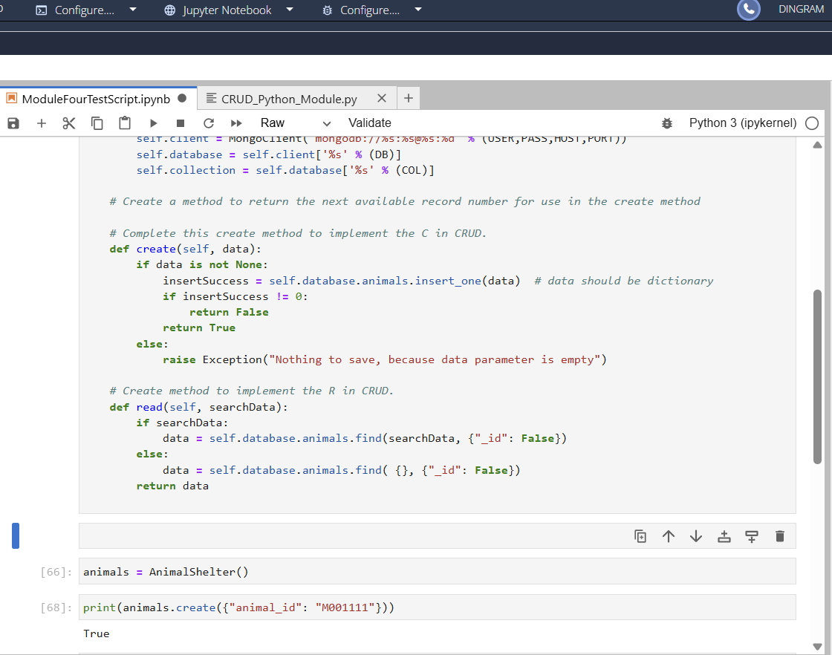

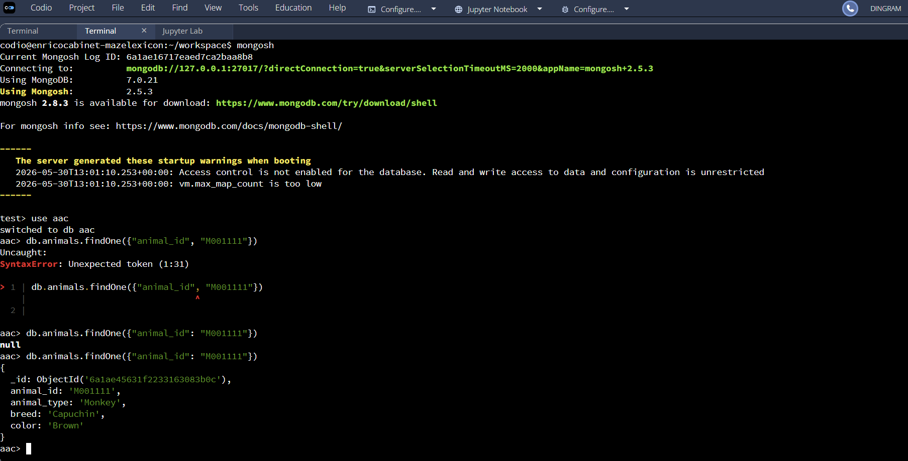

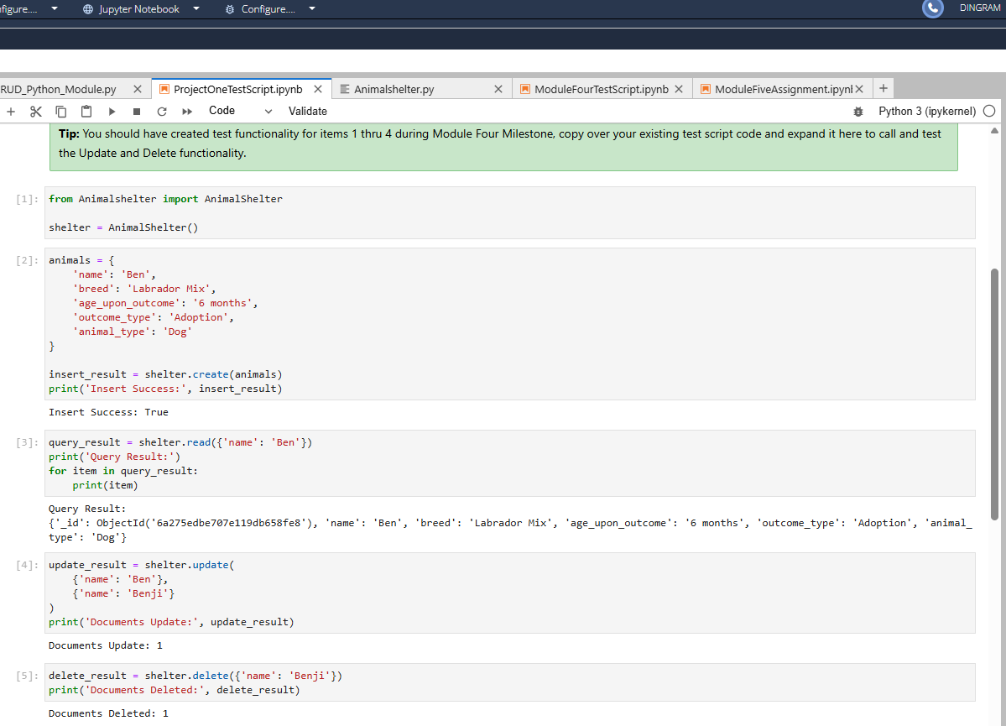

Roadmap/Features (Optional)
Provide an open issues list of proposed features (and known issues). If you have ideas for releases in the future, it is a good idea to list them in the README. What makes your project stand out?
Note: This section is optional for the purposes of this assignment. If you choose not to fill out this section, remove it from your final README file.

Contact
Your name: Daniel Ingram

